**Week 2 Profile**

Things Achieved:  
As per scheduled I started working on interfacing the accelerometer and the magnetometer with the STM32 board via the I2C pins and interfacing the SD card with the board by using the SPI driver. While interfacing the magnetometer and the accelerometer, I wasn’t getting any output on the serial for some reason. I debugged the problem with the use of printf() and by interchanging the sequence of statements. However, I was not getting the desired output on serialT when I inserted the logging function. I am trying to use the GDB technique to debug the same. For interfacing the SD card, I ran into the problems as I had messed up the connections and the files were not being written to the card. Also the files that are already existing on the card are not getting erased. I will be consulting the professor in this week’s lab to solve this issue.

Plans for the current week:  
Discussing the issue of the SD card with the professor and getting it to the log the data from the accelerometer and the magnetometer. Also starting the work on the GPS receiver and storing it in a CSV format on a file in the SD card. I hope to finalize the design for the web application and use the prototype for next week’s lab. Once the logging function starts we can start testing the function to come up with the logic for the estimator function.

Project Schedule:

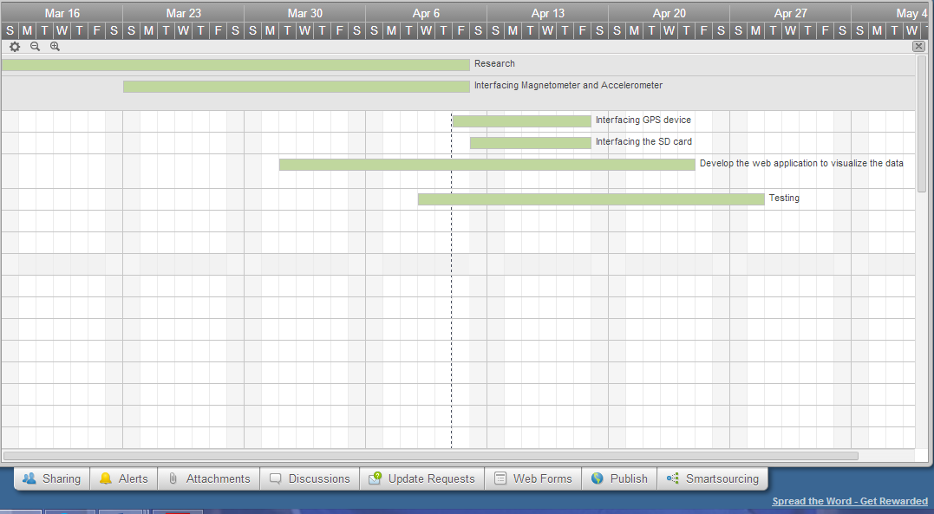

|  |  |  |  |
| --- | --- | --- | --- |
| Category | Design Objective | Deliverable | Status |
| Power | Battery Life | The battery can last for months depending upon the frequency with which it is used. |  |
| Power | Battery Availability | The system can work on commercially available 9V battery. |  |
| User Interface | Web Access | Web application should be in place to enable the user to visualize the data. | Started |
| Data Logging | Information Storage | The SD card can log in a large number of data entries. | Started |
| Mechanical | Environmental | The system should work fine in the temperature range of -30 C to 70 C. |  |